alpha = 2

1 run......

training 1 epoch...

16.579941749572754 seconds used......

1 training finished! average train loss: 2.179541672979082

total clf loss: 54.52771347761154 total adv loss: 33.76331055164337

evaluating...

Confusion matrix, without normalization

[[ 50 36 10]

[ 35 263 57]

[ 60 169 490]]

Normalized confusion matrix

[[0.52083333 0.375 0.10416667]

[0.09859155 0.74084507 0.16056338]

[0.08344924 0.23504868 0.68150209]]

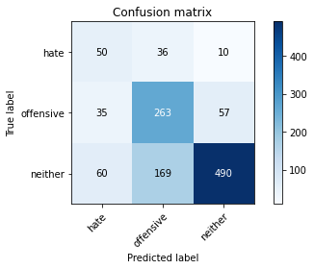

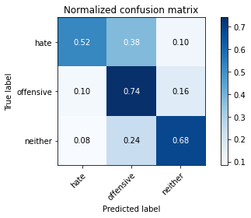

precision recall f1-score support

hate 0.34 0.52 0.41 96

offensive 0.56 0.74 0.64 355

neither 0.88 0.68 0.77 719

accuracy 0.69 1170

macro avg 0.60 0.65 0.61 1170

weighted avg 0.74 0.69 0.70 1170

average eval_loss: 0.7436165698504044, accuracy: 0.6863247863247863

training 2 epoch...

16.684396743774414 seconds used......

2 training finished! average train loss: 1.5627471485308237

total clf loss: 37.772712498903275 total adv loss: 24.87056404352188

evaluating...

Confusion matrix, without normalization

[[ 79 8 9]

[ 87 182 86]

[ 84 71 564]]

Normalized confusion matrix

[[0.82291667 0.08333333 0.09375 ]

[0.24507042 0.51267606 0.24225352]

[0.11682893 0.09874826 0.78442281]]

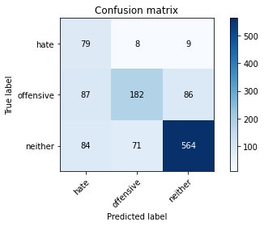

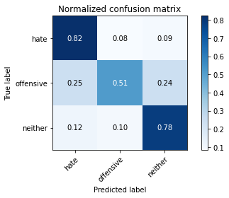

precision recall f1-score support

hate 0.32 0.82 0.46 96

offensive 0.70 0.51 0.59 355

neither 0.86 0.78 0.82 719

accuracy 0.71 1170

macro avg 0.62 0.71 0.62 1170

weighted avg 0.76 0.71 0.72 1170

average eval_loss: 0.6841852816484743, accuracy: 0.7051282051282052

training 3 epoch...

16.560436964035034 seconds used......

3 training finished! average train loss: 0.8545246156198638

total clf loss: 20.74248830974102 total adv loss: 13.555445006117225

evaluating...

Confusion matrix, without normalization

[[ 56 17 23]

[ 34 205 116]

[ 27 62 630]]

Normalized confusion matrix

[[0.58333333 0.17708333 0.23958333]

[0.09577465 0.57746479 0.32676056]

[0.03755216 0.08623088 0.87621697]]

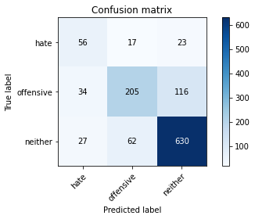

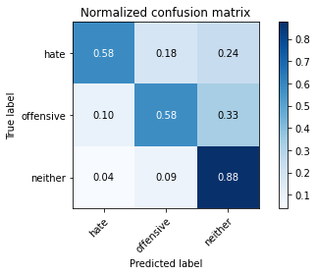

precision recall f1-score support

hate 0.48 0.58 0.53 96

offensive 0.72 0.58 0.64 355

neither 0.82 0.88 0.85 719

accuracy 0.76 1170

macro avg 0.67 0.68 0.67 1170

weighted avg 0.76 0.76 0.76 1170

average eval_loss: 0.6315754313590163, accuracy: 0.7615384615384615

training 4 epoch...

16.74109125137329 seconds used......

4 training finished! average train loss: 0.39003506635448765

total clf loss: 10.85792863741517 total adv loss: 5.4920174912549555

evaluating...

Confusion matrix, without normalization

[[ 80 11 5]

[ 85 188 82]

[ 96 83 540]]

Normalized confusion matrix

[[0.83333333 0.11458333 0.05208333]

[0.23943662 0.52957746 0.23098592]

[0.13351878 0.11543811 0.75104312]]

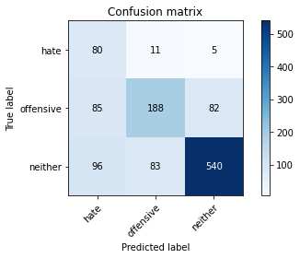

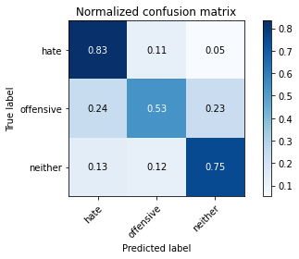

precision recall f1-score support

hate 0.31 0.83 0.45 96

offensive 0.67 0.53 0.59 355

neither 0.86 0.75 0.80 719

accuracy 0.69 1170

macro avg 0.61 0.70 0.61 1170

weighted avg 0.76 0.69 0.71 1170

average eval_loss: 0.892782612877377, accuracy: 0.6905982905982906

training 5 epoch...

16.76940083503723 seconds used......

5 training finished! average train loss: 0.19896406706954753

total clf loss: 5.205838305875659 total adv loss: 2.9680747310630977

evaluating...

Confusion matrix, without normalization

[[ 75 14 7]

[ 65 238 52]

[ 78 138 503]]

Normalized confusion matrix

[[0.78125 0.14583333 0.07291667]

[0.18309859 0.67042254 0.14647887]

[0.10848401 0.19193324 0.69958275]]

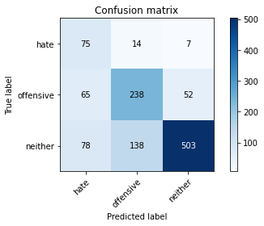

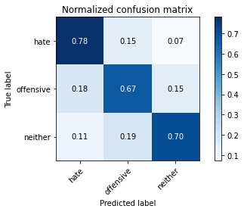

precision recall f1-score support

hate 0.34 0.78 0.48 96

offensive 0.61 0.67 0.64 355

neither 0.90 0.70 0.79 719

accuracy 0.70 1170

macro avg 0.62 0.72 0.63 1170

weighted avg 0.76 0.70 0.72 1170

average eval_loss: 1.0446259061158714, accuracy: 0.6974358974358974

training 6 epoch...

16.709186792373657 seconds used......

6 training finished! average train loss: 0.13878552642251765

total clf loss: 3.517239867709577 total adv loss: 2.127374837989919

evaluating...

Confusion matrix, without normalization

[[ 79 12 5]

[ 77 205 73]

[ 96 89 534]]

Normalized confusion matrix

[[0.82291667 0.125 0.05208333]

[0.21690141 0.57746479 0.2056338 ]

[0.13351878 0.12378303 0.74269819]]

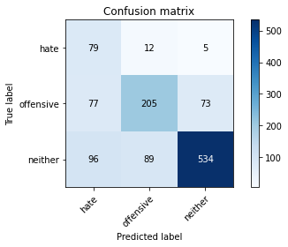

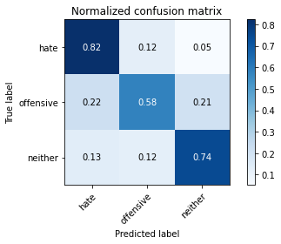

precision recall f1-score support

hate 0.31 0.82 0.45 96

offensive 0.67 0.58 0.62 355

neither 0.87 0.74 0.80 719

accuracy 0.70 1170

macro avg 0.62 0.71 0.63 1170

weighted avg 0.77 0.70 0.72 1170

average eval_loss: 1.0357806687637912, accuracy: 0.6991452991452991

training 7 epoch...

16.638333320617676 seconds used......

7 training finished! average train loss: 0.06036879323905201

total clf loss: 1.7674174963030964 total adv loss: 0.8066174471605336

evaluating...

Confusion matrix, without normalization

[[ 74 16 6]

[ 66 232 57]

[ 86 103 530]]

Normalized confusion matrix

[[0.77083333 0.16666667 0.0625 ]

[0.18591549 0.65352113 0.16056338]

[0.11961057 0.14325452 0.73713491]]

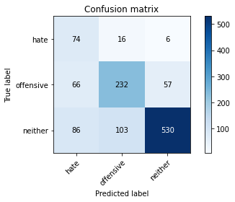

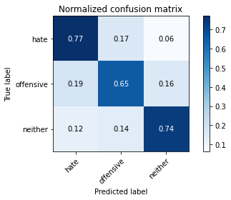

precision recall f1-score support

hate 0.33 0.77 0.46 96

offensive 0.66 0.65 0.66 355

neither 0.89 0.74 0.81 719

accuracy 0.71 1170

macro avg 0.63 0.72 0.64 1170

weighted avg 0.78 0.71 0.73 1170

average eval_loss: 1.1155797824011011, accuracy: 0.7145299145299145

training 8 epoch...

16.75741720199585 seconds used......

8 training finished! average train loss: 0.02318003637317036

total clf loss: 0.8127475036308169 total adv loss: 0.24266726729183574

evaluating...

Confusion matrix, without normalization

[[ 73 13 10]

[ 73 227 55]

[ 80 108 531]]

Normalized confusion matrix

[[0.76041667 0.13541667 0.10416667]

[0.2056338 0.63943662 0.15492958]

[0.11126565 0.15020862 0.73852573]]

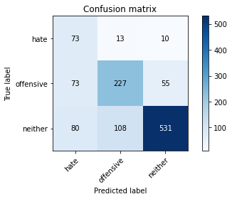

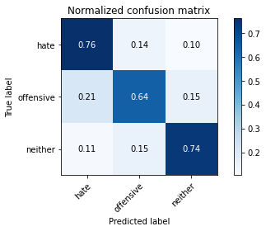

precision recall f1-score support

hate 0.32 0.76 0.45 96

offensive 0.65 0.64 0.65 355

neither 0.89 0.74 0.81 719

accuracy 0.71 1170

macro avg 0.62 0.71 0.64 1170

weighted avg 0.77 0.71 0.73 1170

average eval_loss: 1.1491526471356215, accuracy: 0.7102564102564103

training 9 epoch...

16.69848132133484 seconds used......

9 training finished! average train loss: 0.013233548225668659

total clf loss: 0.5282734961947426 total adv loss: 0.10640260092623066

evaluating...

Confusion matrix, without normalization

[[ 75 13 8]

[ 77 205 73]

[100 68 551]]

Normalized confusion matrix

[[0.78125 0.13541667 0.08333333]

[0.21690141 0.57746479 0.2056338 ]

[0.13908206 0.0945758 0.76634214]]

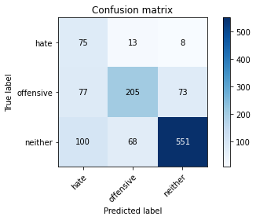

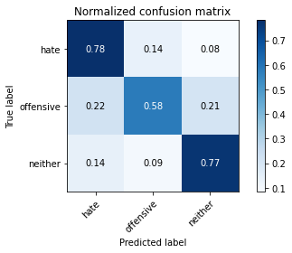

precision recall f1-score support

hate 0.30 0.78 0.43 96

offensive 0.72 0.58 0.64 355

neither 0.87 0.77 0.82 719

accuracy 0.71 1170

macro avg 0.63 0.71 0.63 1170

weighted avg 0.78 0.71 0.73 1170

average eval_loss: 1.343503092305135, accuracy: 0.7102564102564103

training 10 epoch...

16.568593740463257 seconds used......

10 training finished! average train loss: 0.052985910053913746

total clf loss: 1.0202929702354595 total adv loss: 0.9734590028019738

evaluating...

Confusion matrix, without normalization

[[ 83 10 3]

[114 198 43]

[141 99 479]]

Normalized confusion matrix

[[0.86458333 0.10416667 0.03125 ]

[0.32112676 0.55774648 0.12112676]

[0.1961057 0.13769124 0.66620306]]

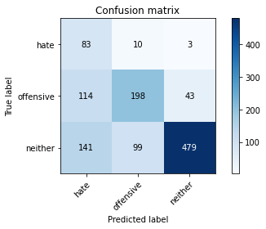

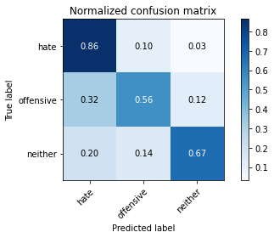

precision recall f1-score support

hate 0.25 0.86 0.38 96

offensive 0.64 0.56 0.60 355

neither 0.91 0.67 0.77 719

accuracy 0.65 1170

macro avg 0.60 0.70 0.58 1170

weighted avg 0.78 0.65 0.69 1170

average eval_loss: 1.645361704341436, accuracy: 0.6495726495726496

2 run......

training 1 epoch...

16.704471588134766 seconds used......

1 training finished! average train loss: 2.22816669515201

total clf loss: 56.101358473300934 total adv loss: 34.33798795938492

evaluating...

Confusion matrix, without normalization

[[ 51 21 24]

[ 68 199 88]

[ 54 100 565]]

Normalized confusion matrix

[[0.53125 0.21875 0.25 ]

[0.1915493 0.56056338 0.24788732]

[0.07510431 0.13908206 0.78581363]]

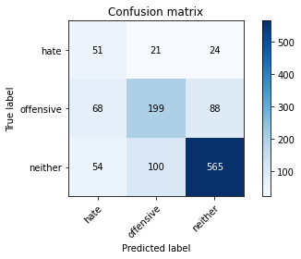

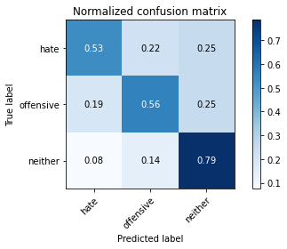

precision recall f1-score support

hate 0.29 0.53 0.38 96

offensive 0.62 0.56 0.59 355

neither 0.83 0.79 0.81 719

accuracy 0.70 1170

macro avg 0.58 0.63 0.59 1170

weighted avg 0.73 0.70 0.71 1170

average eval_loss: 0.7087721314470646, accuracy: 0.6965811965811965

training 2 epoch...

16.66787576675415 seconds used......

2 training finished! average train loss: 1.654436549970082

total clf loss: 38.12089717388153 total adv loss: 27.26377509534359

evaluating...

Confusion matrix, without normalization

[[ 86 5 5]

[116 138 101]

[ 99 37 583]]

Normalized confusion matrix

[[0.89583333 0.05208333 0.05208333]

[0.32676056 0.38873239 0.28450704]

[0.13769124 0.05146036 0.8108484 ]]

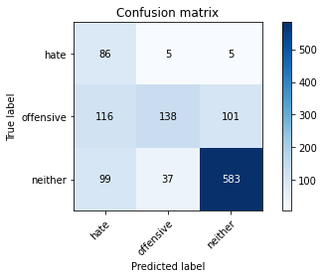

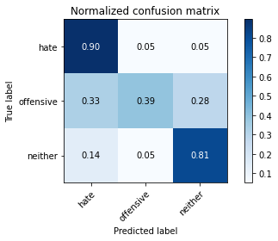

precision recall f1-score support

hate 0.29 0.90 0.43 96

offensive 0.77 0.39 0.52 355

neither 0.85 0.81 0.83 719

accuracy 0.69 1170

macro avg 0.63 0.70 0.59 1170

weighted avg 0.78 0.69 0.70 1170

average eval_loss: 0.736616280624422, accuracy: 0.6897435897435897

training 3 epoch...

16.58396553993225 seconds used......

3 training finished! average train loss: 0.906454301838364

total clf loss: 21.23353249579668 total adv loss: 14.763954184949398

evaluating...

Confusion matrix, without normalization

[[ 72 19 5]

[ 55 236 64]

[ 60 96 563]]

Normalized confusion matrix

[[0.75 0.19791667 0.05208333]

[0.15492958 0.66478873 0.18028169]

[0.08344924 0.13351878 0.78303199]]

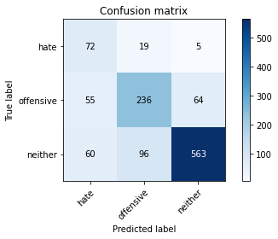

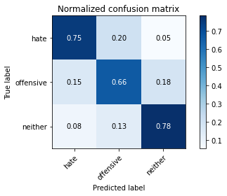

precision recall f1-score support

hate 0.39 0.75 0.51 96

offensive 0.67 0.66 0.67 355

neither 0.89 0.78 0.83 719

accuracy 0.74 1170

macro avg 0.65 0.73 0.67 1170

weighted avg 0.78 0.74 0.76 1170

average eval_loss: 0.7010526899564065, accuracy: 0.7444444444444445

training 4 epoch...

16.584134817123413 seconds used......

4 training finished! average train loss: 0.3930919636040926

total clf loss: 10.212222512811422 total adv loss: 5.9004637552425265

evaluating...

Confusion matrix, without normalization

[[ 75 17 4]

[ 85 227 43]

[ 86 134 499]]

Normalized confusion matrix

[[0.78125 0.17708333 0.04166667]

[0.23943662 0.63943662 0.12112676]

[0.11961057 0.18636996 0.69401947]]

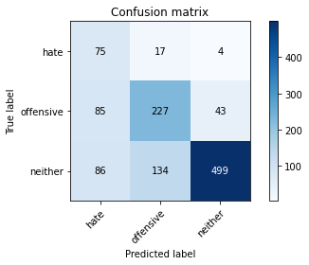

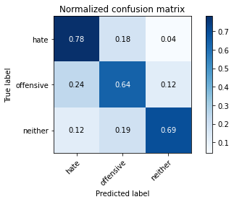

precision recall f1-score support

hate 0.30 0.78 0.44 96

offensive 0.60 0.64 0.62 355

neither 0.91 0.69 0.79 719

accuracy 0.68 1170

macro avg 0.61 0.70 0.62 1170

weighted avg 0.77 0.68 0.71 1170

average eval_loss: 0.9623641487905534, accuracy: 0.6846153846153846

training 5 epoch...

16.675406455993652 seconds used......

5 training finished! average train loss: 0.1526043565744268

total clf loss: 4.698513317853212 total adv loss: 1.923665325914044

evaluating...

Confusion matrix, without normalization

[[ 73 18 5]

[ 62 240 53]

[ 83 109 527]]

Normalized confusion matrix

[[0.76041667 0.1875 0.05208333]

[0.17464789 0.67605634 0.14929577]

[0.11543811 0.15159944 0.73296245]]

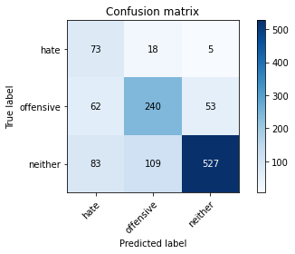

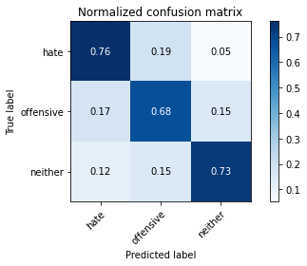

precision recall f1-score support

hate 0.33 0.76 0.46 96

offensive 0.65 0.68 0.66 355

neither 0.90 0.73 0.81 719

accuracy 0.72 1170

macro avg 0.63 0.72 0.65 1170

weighted avg 0.78 0.72 0.74 1170

average eval_loss: 1.0615563422946606, accuracy: 0.717948717948718

training 6 epoch...

16.66136908531189 seconds used......

6 training finished! average train loss: 0.11801751526737851

total clf loss: 2.770956091582775 total adv loss: 1.919012425962137

evaluating...

Confusion matrix, without normalization

[[ 69 13 14]

[ 60 200 95]

[ 42 70 607]]

Normalized confusion matrix

[[0.71875 0.13541667 0.14583333]

[0.16901408 0.56338028 0.26760563]

[0.05841446 0.09735744 0.84422809]]

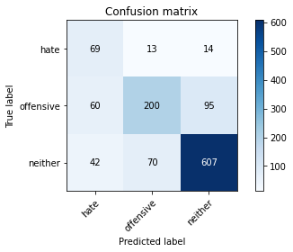

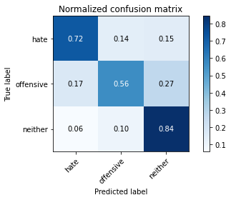

precision recall f1-score support

hate 0.40 0.72 0.52 96

offensive 0.71 0.56 0.63 355

neither 0.85 0.84 0.85 719

accuracy 0.75 1170

macro avg 0.65 0.71 0.66 1170

weighted avg 0.77 0.75 0.75 1170

average eval_loss: 0.9549597388101836, accuracy: 0.7487179487179487

training 7 epoch...

16.588369607925415 seconds used......

7 training finished! average train loss: 0.10835949027179075

total clf loss: 2.7512591327540576 total adv loss: 1.6584361787536182

evaluating...

Confusion matrix, without normalization

[[ 73 20 3]

[ 57 257 41]

[ 73 152 494]]

Normalized confusion matrix

[[0.76041667 0.20833333 0.03125 ]

[0.16056338 0.72394366 0.11549296]

[0.1015299 0.21140473 0.68706537]]

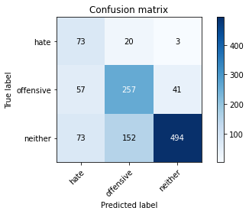

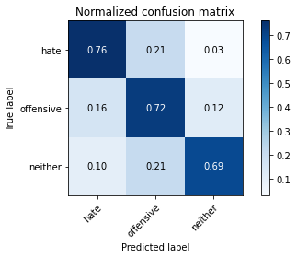

precision recall f1-score support

hate 0.36 0.76 0.49 96

offensive 0.60 0.72 0.66 355

neither 0.92 0.69 0.79 719

accuracy 0.70 1170

macro avg 0.63 0.72 0.64 1170

weighted avg 0.78 0.70 0.72 1170

average eval_loss: 1.303496325420121, accuracy: 0.7042735042735043

training 8 epoch...

16.704792976379395 seconds used......

8 training finished! average train loss: 0.05153692526593139

total clf loss: 1.3895866700913757 total adv loss: 0.7482405791233759

evaluating...

Confusion matrix, without normalization

[[ 78 16 2]

[ 78 206 71]

[ 85 85 549]]

Normalized confusion matrix

[[0.8125 0.16666667 0.02083333]

[0.21971831 0.58028169 0.2 ]

[0.11821975 0.11821975 0.7635605 ]]

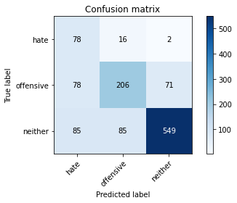

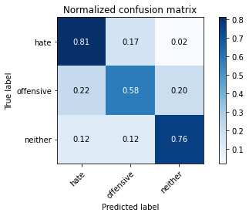

precision recall f1-score support

hate 0.32 0.81 0.46 96

offensive 0.67 0.58 0.62 355

neither 0.88 0.76 0.82 719

accuracy 0.71 1170

macro avg 0.63 0.72 0.63 1170

weighted avg 0.77 0.71 0.73 1170

average eval_loss: 1.3408332249875796, accuracy: 0.711965811965812

training 9 epoch...

16.720520973205566 seconds used......

9 training finished! average train loss: 0.011936691265353667

total clf loss: 0.6110785224009305 total adv loss: 0.028688092563243117

evaluating...

Confusion matrix, without normalization

[[ 79 16 1]

[ 77 220 58]

[ 92 101 526]]

Normalized confusion matrix

[[0.82291667 0.16666667 0.01041667]

[0.21690141 0.61971831 0.16338028]

[0.12795549 0.14047288 0.73157163]]

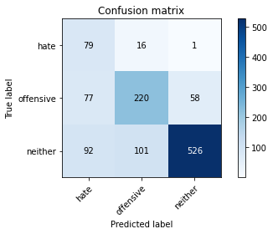

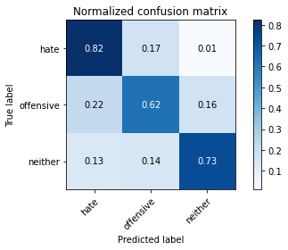

precision recall f1-score support

hate 0.32 0.82 0.46 96

offensive 0.65 0.62 0.64 355

neither 0.90 0.73 0.81 719

accuracy 0.71 1170

macro avg 0.62 0.72 0.63 1170

weighted avg 0.78 0.71 0.73 1170

average eval_loss: 1.4766674072055492, accuracy: 0.7051282051282052

training 10 epoch...

16.627969980239868 seconds used......

10 training finished! average train loss: 0.022183973907626102

total clf loss: 0.6511500953929499 total adv loss: 0.29557621693311376

evaluating...

Confusion matrix, without normalization

[[ 68 24 4]

[ 48 243 64]

[ 60 135 524]]

Normalized confusion matrix

[[0.70833333 0.25 0.04166667]

[0.13521127 0.68450704 0.18028169]

[0.08344924 0.18776078 0.72878999]]

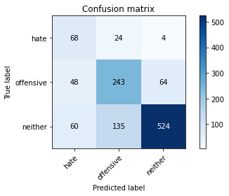

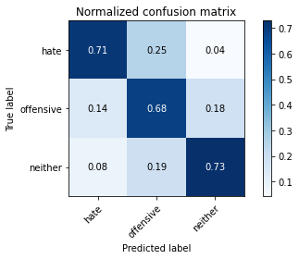

precision recall f1-score support

hate 0.39 0.71 0.50 96

offensive 0.60 0.68 0.64 355

neither 0.89 0.73 0.80 719

accuracy 0.71 1170

macro avg 0.63 0.71 0.65 1170

weighted avg 0.76 0.71 0.73 1170

average eval_loss: 1.3249514592906175, accuracy: 0.7136752136752137

3 run......

training 1 epoch...

16.573664665222168 seconds used......

1 training finished! average train loss: 2.207459643483162

total clf loss: 57.11926746368408 total adv loss: 33.249236315488815

evaluating...

Confusion matrix, without normalization

[[ 52 23 21]

[ 74 198 83]

[ 86 102 531]]

Normalized confusion matrix

[[0.54166667 0.23958333 0.21875 ]

[0.2084507 0.55774648 0.23380282]

[0.11961057 0.1418637 0.73852573]]

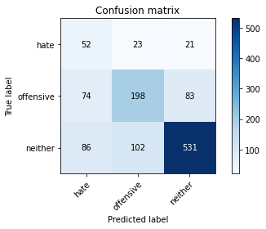

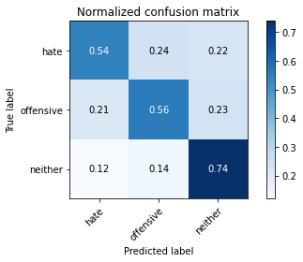

precision recall f1-score support

hate 0.25 0.54 0.34 96

offensive 0.61 0.56 0.58 355

neither 0.84 0.74 0.78 719

accuracy 0.67 1170

macro avg 0.56 0.61 0.57 1170

weighted avg 0.72 0.67 0.69 1170

average eval_loss: 0.8280541805897729, accuracy: 0.6675213675213675

training 2 epoch...

16.608203887939453 seconds used......

2 training finished! average train loss: 1.6635473115103585

total clf loss: 39.67557156085968 total adv loss: 26.741539150476456

evaluating...

Confusion matrix, without normalization

[[ 68 14 14]

[ 86 189 80]

[ 94 88 537]]

Normalized confusion matrix

[[0.70833333 0.14583333 0.14583333]

[0.24225352 0.53239437 0.22535211]

[0.13073713 0.12239221 0.74687065]]

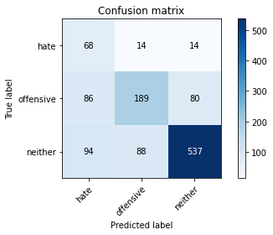

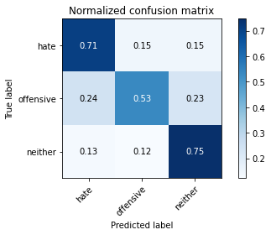

precision recall f1-score support

hate 0.27 0.71 0.40 96

offensive 0.65 0.53 0.59 355

neither 0.85 0.75 0.80 719

accuracy 0.68 1170

macro avg 0.59 0.66 0.59 1170

weighted avg 0.74 0.68 0.70 1170

average eval_loss: 0.737088689864692, accuracy: 0.6786324786324787

training 3 epoch...

16.556244134902954 seconds used......

3 training finished! average train loss: 0.8708124634410653

total clf loss: 22.90731678903103 total adv loss: 12.929090775549412

evaluating...

Confusion matrix, without normalization

[[ 80 14 2]

[ 63 267 25]

[119 219 381]]

Normalized confusion matrix

[[0.83333333 0.14583333 0.02083333]

[0.17746479 0.75211268 0.07042254]

[0.16550765 0.30458971 0.52990264]]

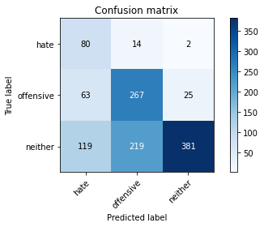

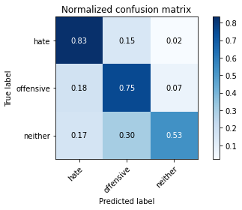

precision recall f1-score support

hate 0.31 0.83 0.45 96

offensive 0.53 0.75 0.62 355

neither 0.93 0.53 0.68 719

accuracy 0.62 1170

macro avg 0.59 0.71 0.58 1170

weighted avg 0.76 0.62 0.64 1170

average eval_loss: 1.0941582509016587, accuracy: 0.6222222222222222

training 4 epoch...

16.55225157737732 seconds used......

4 training finished! average train loss: 0.4088389673935516

total clf loss: 10.965658579021692 total adv loss: 5.964661861769855

evaluating...

Confusion matrix, without normalization

[[ 60 34 2]

[ 35 292 28]

[ 64 228 427]]

Normalized confusion matrix

[[0.625 0.35416667 0.02083333]

[0.09859155 0.82253521 0.07887324]

[0.08901252 0.31710709 0.59388039]]

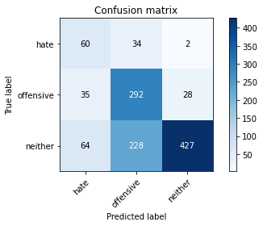

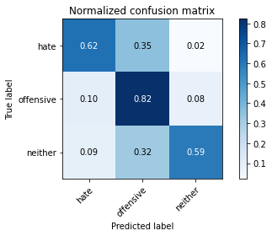

precision recall f1-score support

hate 0.38 0.62 0.47 96

offensive 0.53 0.82 0.64 355

neither 0.93 0.59 0.73 719

accuracy 0.67 1170

macro avg 0.61 0.68 0.61 1170

weighted avg 0.77 0.67 0.68 1170

average eval_loss: 1.1398478013984228, accuracy: 0.6658119658119658

training 5 epoch...

16.69955015182495 seconds used......

5 training finished! average train loss: 0.3632432972746236

total clf loss: 8.854562671855092 total adv loss: 5.743530943989754

evaluating...

Confusion matrix, without normalization

[[ 71 13 12]

[ 64 214 77]

[ 53 88 578]]

Normalized confusion matrix

[[0.73958333 0.13541667 0.125 ]

[0.18028169 0.6028169 0.21690141]

[0.07371349 0.12239221 0.8038943 ]]

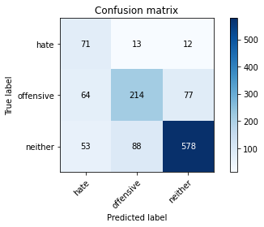

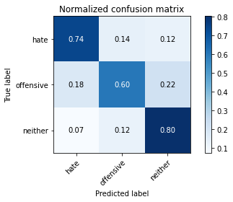

precision recall f1-score support

hate 0.38 0.74 0.50 96

offensive 0.68 0.60 0.64 355

neither 0.87 0.80 0.83 719

accuracy 0.74 1170

macro avg 0.64 0.72 0.66 1170

weighted avg 0.77 0.74 0.75 1170

average eval_loss: 0.845219233783625, accuracy: 0.7376068376068377

training 6 epoch...

16.641017198562622 seconds used......

6 training finished! average train loss: 0.06713311527190464

total clf loss: 2.3411095878109336 total adv loss: 0.7091724214988062

evaluating...

Confusion matrix, without normalization

[[ 90 4 2]

[115 184 56]

[124 101 494]]

Normalized confusion matrix

[[0.9375 0.04166667 0.02083333]

[0.32394366 0.51830986 0.15774648]

[0.17246175 0.14047288 0.68706537]]

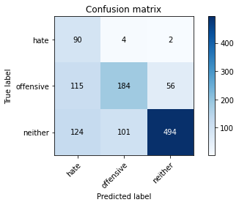

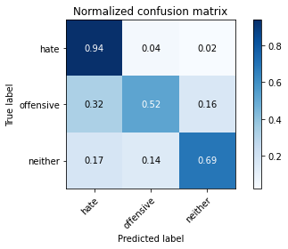

precision recall f1-score support

hate 0.27 0.94 0.42 96

offensive 0.64 0.52 0.57 355

neither 0.89 0.69 0.78 719

accuracy 0.66 1170

macro avg 0.60 0.71 0.59 1170

weighted avg 0.77 0.66 0.69 1170

average eval_loss: 1.3784661434464536, accuracy: 0.6564102564102564

training 7 epoch...

16.57130265235901 seconds used......

7 training finished! average train loss: 0.02151977238411616

total clf loss: 0.9934856619220227 total adv loss: 0.10581079455459985

evaluating...

Confusion matrix, without normalization

[[ 80 9 7]

[ 98 189 68]

[102 82 535]]

Normalized confusion matrix

[[0.83333333 0.09375 0.07291667]

[0.27605634 0.53239437 0.1915493 ]

[0.1418637 0.11404729 0.74408901]]

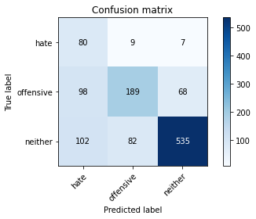

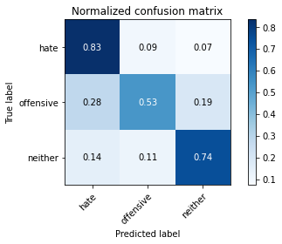

precision recall f1-score support

hate 0.29 0.83 0.43 96

offensive 0.68 0.53 0.60 355

neither 0.88 0.74 0.81 719

accuracy 0.69 1170

macro avg 0.61 0.70 0.61 1170

weighted avg 0.77 0.69 0.71 1170

average eval_loss: 1.3319359063091925, accuracy: 0.6871794871794872

training 8 epoch...

16.645987510681152 seconds used......

8 training finished! average train loss: 0.03751543304991044

total clf loss: 0.8740495458478108 total adv loss: 0.6134073496414203

evaluating...

Confusion matrix, without normalization

[[ 60 23 13]

[ 48 244 63]

[ 48 131 540]]

Normalized confusion matrix

[[0.625 0.23958333 0.13541667]

[0.13521127 0.68732394 0.17746479]

[0.06675939 0.1821975 0.75104312]]

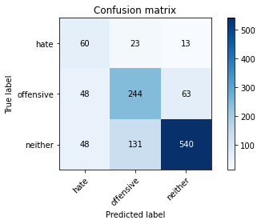

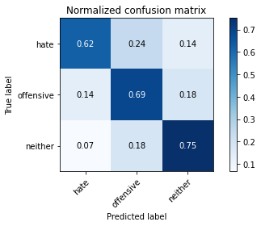

precision recall f1-score support

hate 0.38 0.62 0.48 96

offensive 0.61 0.69 0.65 355

neither 0.88 0.75 0.81 719

accuracy 0.72 1170

macro avg 0.62 0.69 0.64 1170

weighted avg 0.76 0.72 0.73 1170

average eval_loss: 1.2190664067106731, accuracy: 0.7213675213675214

training 9 epoch...

16.67209243774414 seconds used......

9 training finished! average train loss: 0.08638350994858358

total clf loss: 1.5814115018583834 total adv loss: 1.628032516920939

evaluating...

Confusion matrix, without normalization

[[ 81 8 7]

[ 76 205 74]

[ 85 85 549]]

Normalized confusion matrix

[[0.84375 0.08333333 0.07291667]

[0.21408451 0.57746479 0.2084507 ]

[0.11821975 0.11821975 0.7635605 ]]

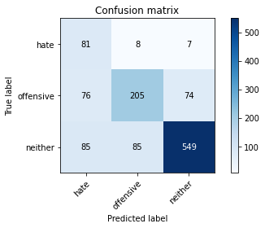

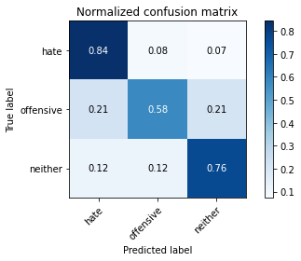

precision recall f1-score support

hate 0.33 0.84 0.48 96

offensive 0.69 0.58 0.63 355

neither 0.87 0.76 0.81 719

accuracy 0.71 1170

macro avg 0.63 0.73 0.64 1170

weighted avg 0.77 0.71 0.73 1170

average eval_loss: 1.2827642787311038, accuracy: 0.7136752136752137

training 10 epoch...

16.574808597564697 seconds used......

10 training finished! average train loss: 0.04677984578094246

total clf loss: 1.0258844274794683 total adv loss: 0.7968934581367648

evaluating...

Confusion matrix, without normalization

[[ 75 8 13]

[ 89 175 91]

[ 73 60 586]]

Normalized confusion matrix

[[0.78125 0.08333333 0.13541667]

[0.25070423 0.49295775 0.25633803]

[0.1015299 0.08344924 0.81502086]]

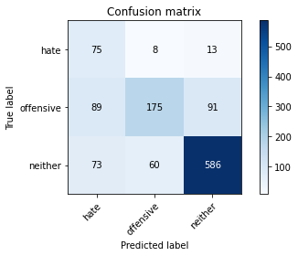

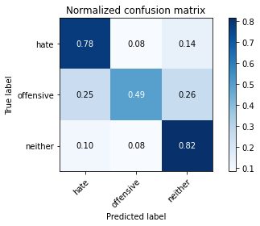

precision recall f1-score support

hate 0.32 0.78 0.45 96

offensive 0.72 0.49 0.59 355

neither 0.85 0.82 0.83 719

accuracy 0.71 1170

macro avg 0.63 0.70 0.62 1170

weighted avg 0.77 0.71 0.73 1170

average eval_loss: 1.3281323033369195, accuracy: 0.7145299145299145

4 run......

training 1 epoch...

16.542911529541016 seconds used......

1 training finished! average train loss: 2.2652765533753803

total clf loss: 57.826353311538696 total adv loss: 34.514566510915756

evaluating...

Confusion matrix, without normalization

[[ 58 27 11]

[ 67 255 33]

[126 202 391]]

Normalized confusion matrix

[[0.60416667 0.28125 0.11458333]

[0.18873239 0.71830986 0.09295775]

[0.17524339 0.28094576 0.54381085]]

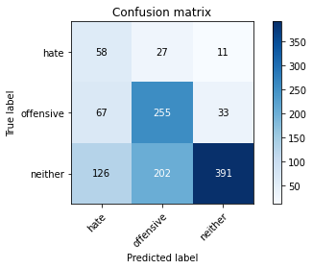

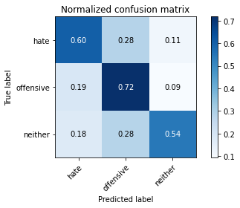

precision recall f1-score support

hate 0.23 0.60 0.33 96

offensive 0.53 0.72 0.61 355

neither 0.90 0.54 0.68 719

accuracy 0.60 1170

macro avg 0.55 0.62 0.54 1170

weighted avg 0.73 0.60 0.63 1170

average eval_loss: 0.9063326595193248, accuracy: 0.6017094017094017

training 2 epoch...

16.62748074531555 seconds used......

2 training finished! average train loss: 1.675939685532025

total clf loss: 40.330711871385574 total adv loss: 26.760955214500427

evaluating...

Confusion matrix, without normalization

[[ 71 17 8]

[ 65 228 62]

[ 75 126 518]]

Normalized confusion matrix

[[0.73958333 0.17708333 0.08333333]

[0.18309859 0.64225352 0.17464789]

[0.10431154 0.17524339 0.72044506]]

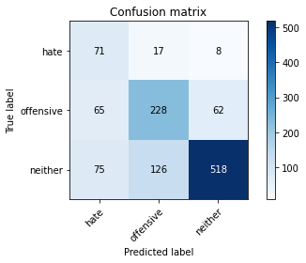

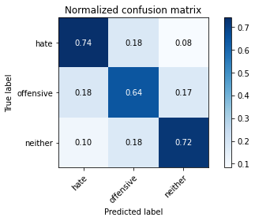

precision recall f1-score support

hate 0.34 0.74 0.46 96

offensive 0.61 0.64 0.63 355

neither 0.88 0.72 0.79 719

accuracy 0.70 1170

macro avg 0.61 0.70 0.63 1170

weighted avg 0.76 0.70 0.72 1170

average eval_loss: 0.7012137285733627, accuracy: 0.6982905982905983

training 3 epoch...

16.61459231376648 seconds used......

3 training finished! average train loss: 0.9575184679457119

total clf loss: 23.478381544351578 total adv loss: 15.071326341480017

evaluating...

Confusion matrix, without normalization

[[ 79 15 2]

[ 94 234 27]

[145 146 428]]

Normalized confusion matrix

[[0.82291667 0.15625 0.02083333]

[0.26478873 0.65915493 0.07605634]

[0.20166898 0.20305981 0.59527121]]

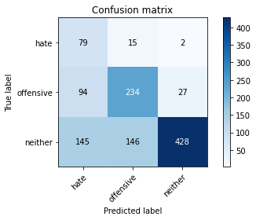

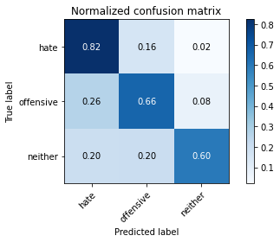

precision recall f1-score support

hate 0.25 0.82 0.38 96

offensive 0.59 0.66 0.62 355

neither 0.94 0.60 0.73 719

accuracy 0.63 1170

macro avg 0.59 0.69 0.58 1170

weighted avg 0.78 0.63 0.67 1170

average eval_loss: 0.966919873730611, accuracy: 0.6333333333333333

training 4 epoch...

16.555633544921875 seconds used......

4 training finished! average train loss: 0.27517254929989576

total clf loss: 8.723480306565762 total adv loss: 3.343091249698773

evaluating...

Confusion matrix, without normalization

[[ 54 33 9]

[ 37 255 63]

[ 57 120 542]]

Normalized confusion matrix

[[0.5625 0.34375 0.09375 ]

[0.10422535 0.71830986 0.17746479]

[0.07927677 0.16689847 0.75382476]]

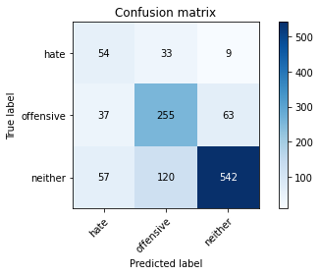

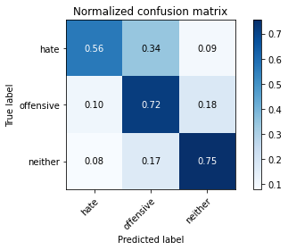

precision recall f1-score support

hate 0.36 0.56 0.44 96

offensive 0.62 0.72 0.67 355

neither 0.88 0.75 0.81 719

accuracy 0.73 1170

macro avg 0.62 0.68 0.64 1170

weighted avg 0.76 0.73 0.74 1170

average eval_loss: 0.8090542357856945, accuracy: 0.7273504273504273

training 5 epoch...

16.61696982383728 seconds used......

5 training finished! average train loss: 0.4120550528833909

total clf loss: 8.82387400045991 total adv loss: 7.1256045126356184

evaluating...

Confusion matrix, without normalization

[[ 71 20 5]

[ 80 223 52]

[114 102 503]]

Normalized confusion matrix

[[0.73958333 0.20833333 0.05208333]

[0.22535211 0.62816901 0.14647887]

[0.15855355 0.1418637 0.69958275]]

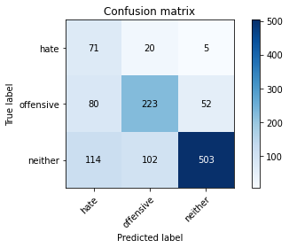

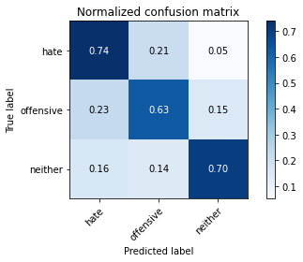

precision recall f1-score support

hate 0.27 0.74 0.39 96

offensive 0.65 0.63 0.64 355

neither 0.90 0.70 0.79 719

accuracy 0.68 1170

macro avg 0.60 0.69 0.61 1170

weighted avg 0.77 0.68 0.71 1170

average eval_loss: 0.991771147917893, accuracy: 0.6811965811965812

training 6 epoch...

16.646982669830322 seconds used......

6 training finished! average train loss: 0.15796879276500217

total clf loss: 4.504842998459935 total adv loss: 2.170704702526564

evaluating...

Confusion matrix, without normalization

[[ 77 17 2]

[ 84 243 28]

[151 152 416]]

Normalized confusion matrix

[[0.80208333 0.17708333 0.02083333]

[0.23661972 0.68450704 0.07887324]

[0.21001391 0.21140473 0.57858136]]

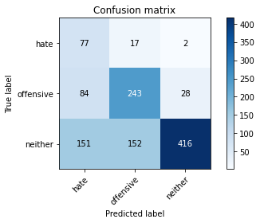

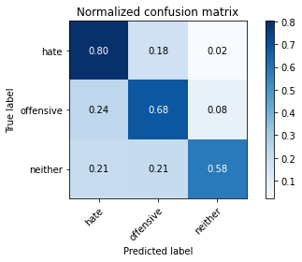

precision recall f1-score support

hate 0.25 0.80 0.38 96

offensive 0.59 0.68 0.63 355

neither 0.93 0.58 0.71 719

accuracy 0.63 1170

macro avg 0.59 0.69 0.58 1170

weighted avg 0.77 0.63 0.66 1170

average eval_loss: 1.3896872795234292, accuracy: 0.629059829059829

training 7 epoch...

16.5783109664917 seconds used......

7 training finished! average train loss: 0.06863056301205818

total clf loss: 2.1986384843476117 total adv loss: 0.8223365550802555

evaluating...

Confusion matrix, without normalization

[[ 66 19 11]

[ 64 237 54]

[ 82 122 515]]

Normalized confusion matrix

[[0.6875 0.19791667 0.11458333]

[0.18028169 0.66760563 0.15211268]

[0.11404729 0.16968011 0.7162726 ]]

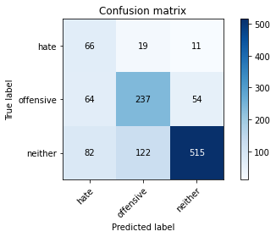

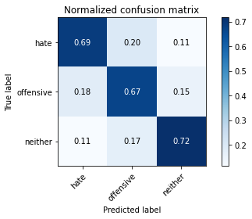

precision recall f1-score support

hate 0.31 0.69 0.43 96

offensive 0.63 0.67 0.65 355

neither 0.89 0.72 0.79 719

accuracy 0.70 1170

macro avg 0.61 0.69 0.62 1170

weighted avg 0.76 0.70 0.72 1170

average eval_loss: 1.1703187782885665, accuracy: 0.6991452991452991

training 8 epoch...

16.604868173599243 seconds used......

8 training finished! average train loss: 0.1304349365361434

total clf loss: 2.845741769298911 total adv loss: 2.2293073536420707

evaluating...

Confusion matrix, without normalization

[[ 67 26 3]

[ 52 272 31]

[ 89 195 435]]

Normalized confusion matrix

[[0.69791667 0.27083333 0.03125 ]

[0.14647887 0.76619718 0.08732394]

[0.12378303 0.27121001 0.60500695]]

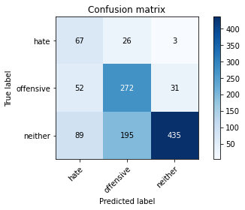

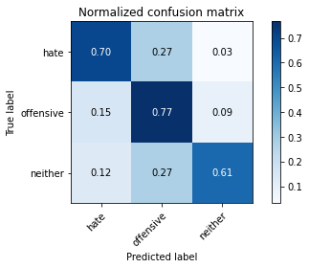

precision recall f1-score support

hate 0.32 0.70 0.44 96

offensive 0.55 0.77 0.64 355

neither 0.93 0.61 0.73 719

accuracy 0.66 1170

macro avg 0.60 0.69 0.60 1170

weighted avg 0.76 0.66 0.68 1170

average eval_loss: 1.497583368067014, accuracy: 0.6615384615384615

training 9 epoch...

16.596542358398438 seconds used......

9 training finished! average train loss: 0.04957721935768079

total clf loss: 1.726700976723805 total adv loss: 0.5248116542061325

evaluating...

Confusion matrix, without normalization

[[ 66 15 15]

[ 91 190 74]

[ 75 67 577]]

Normalized confusion matrix

[[0.6875 0.15625 0.15625 ]

[0.25633803 0.53521127 0.2084507 ]

[0.10431154 0.09318498 0.80250348]]

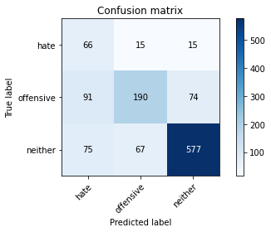

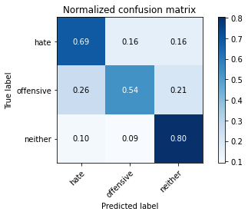

precision recall f1-score support

hate 0.28 0.69 0.40 96

offensive 0.70 0.54 0.61 355

neither 0.87 0.80 0.83 719

accuracy 0.71 1170

macro avg 0.62 0.68 0.61 1170

weighted avg 0.77 0.71 0.73 1170

average eval_loss: 1.174801454200583, accuracy: 0.711965811965812

training 10 epoch...

16.551026344299316 seconds used......

10 training finished! average train loss: 0.014094778583967127

total clf loss: 0.5179063497344032 total adv loss: 0.13570063340375782

evaluating...

Confusion matrix, without normalization

[[ 64 25 7]

[ 50 259 46]

[ 84 151 484]]

Normalized confusion matrix

[[0.66666667 0.26041667 0.07291667]

[0.14084507 0.72957746 0.12957746]

[0.11682893 0.21001391 0.67315716]]

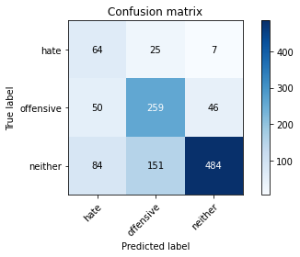

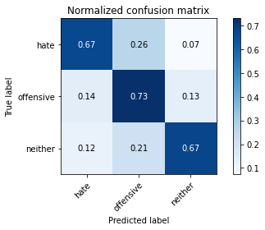

precision recall f1-score support

hate 0.32 0.67 0.44 96

offensive 0.60 0.73 0.66 355

neither 0.90 0.67 0.77 719

accuracy 0.69 1170

macro avg 0.61 0.69 0.62 1170

weighted avg 0.76 0.69 0.71 1170

average eval_loss: 1.4231180442591844, accuracy: 0.6897435897435897

5 run......

training 1 epoch...

16.593698501586914 seconds used......

1 training finished! average train loss: 2.1553248316049576

total clf loss: 54.87332504987717 total adv loss: 32.912432700395584

evaluating...

Confusion matrix, without normalization

[[ 78 8 10]

[113 186 56]

[127 100 492]]

Normalized confusion matrix

[[0.8125 0.08333333 0.10416667]

[0.31830986 0.52394366 0.15774648]

[0.17663421 0.13908206 0.68428373]]

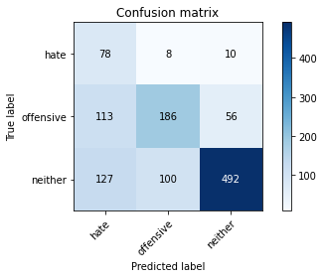

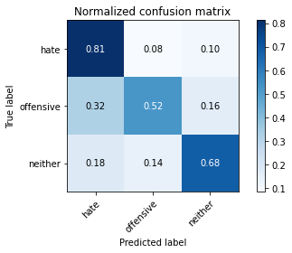

precision recall f1-score support

hate 0.25 0.81 0.38 96

offensive 0.63 0.52 0.57 355

neither 0.88 0.68 0.77 719

accuracy 0.65 1170

macro avg 0.59 0.67 0.57 1170

weighted avg 0.75 0.65 0.68 1170

average eval_loss: 0.7902989114745188, accuracy: 0.6461538461538462

training 2 epoch...

16.655210256576538 seconds used......

2 training finished! average train loss: 1.42897943513734

total clf loss: 34.35861071944237 total adv loss: 22.83211901783943

evaluating...

Confusion matrix, without normalization

[[ 58 35 3]

[ 40 275 40]

[ 93 169 457]]

Normalized confusion matrix

[[0.60416667 0.36458333 0.03125 ]

[0.11267606 0.77464789 0.11267606]

[0.12934631 0.23504868 0.63560501]]

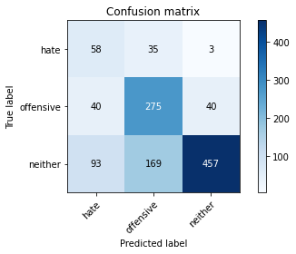

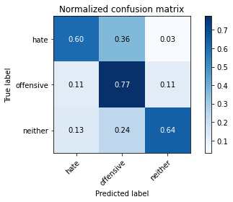

precision recall f1-score support

hate 0.30 0.60 0.40 96

offensive 0.57 0.77 0.66 355

neither 0.91 0.64 0.75 719

accuracy 0.68 1170

macro avg 0.60 0.67 0.60 1170

weighted avg 0.76 0.68 0.69 1170

average eval_loss: 0.7616554993694111, accuracy: 0.6752136752136753

training 3 epoch...

16.627877950668335 seconds used......

3 training finished! average train loss: 0.7881942843752248

total clf loss: 18.765253111720085 total adv loss: 12.686813337728381

evaluating...

Confusion matrix, without normalization

[[ 54 19 23]

[ 34 221 100]

[ 22 78 619]]

Normalized confusion matrix

[[0.5625 0.19791667 0.23958333]

[0.09577465 0.62253521 0.28169014]

[0.03059805 0.10848401 0.86091794]]

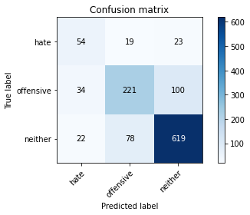

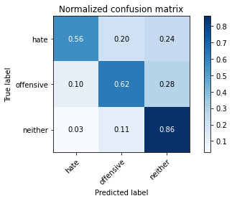

precision recall f1-score support

hate 0.49 0.56 0.52 96

offensive 0.69 0.62 0.66 355

neither 0.83 0.86 0.85 719

accuracy 0.76 1170

macro avg 0.67 0.68 0.68 1170

weighted avg 0.76 0.76 0.76 1170

average eval_loss: 0.6431350367049039, accuracy: 0.764102564102564

training 4 epoch...

16.580504894256592 seconds used......

4 training finished! average train loss: 0.32230718939432074

total clf loss: 10.47418375685811 total adv loss: 3.7875093888724223

evaluating...

Confusion matrix, without normalization

[[ 72 20 4]

[ 56 254 45]

[ 73 143 503]]

Normalized confusion matrix

[[0.75 0.20833333 0.04166667]

[0.15774648 0.71549296 0.12676056]

[0.1015299 0.19888734 0.69958275]]

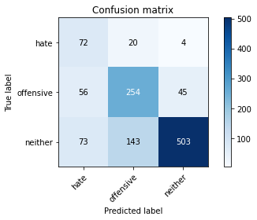

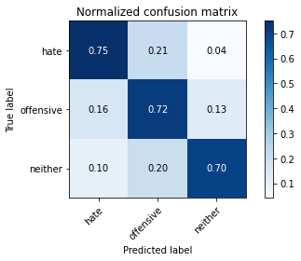

precision recall f1-score support

hate 0.36 0.75 0.48 96

offensive 0.61 0.72 0.66 355

neither 0.91 0.70 0.79 719

accuracy 0.71 1170

macro avg 0.63 0.72 0.64 1170

weighted avg 0.77 0.71 0.73 1170

average eval_loss: 0.9074239205505888, accuracy: 0.7085470085470086

training 5 epoch...

16.64753818511963 seconds used......

5 training finished! average train loss: 0.1497713585517236

total clf loss: 4.057465745136142 total adv loss: 2.1648651301511563

evaluating...

Confusion matrix, without normalization

[[ 82 10 4]

[ 91 220 44]

[107 151 461]]

Normalized confusion matrix

[[0.85416667 0.10416667 0.04166667]

[0.25633803 0.61971831 0.12394366]

[0.1488178 0.21001391 0.64116829]]

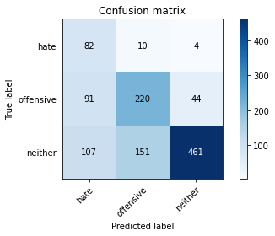

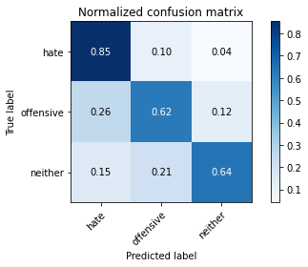

precision recall f1-score support

hate 0.29 0.85 0.44 96

offensive 0.58 0.62 0.60 355

neither 0.91 0.64 0.75 719

accuracy 0.65 1170

macro avg 0.59 0.71 0.59 1170

weighted avg 0.76 0.65 0.68 1170

average eval_loss: 1.183987086607238, accuracy: 0.6521367521367522

training 6 epoch...

16.58932638168335 seconds used......

6 training finished! average train loss: 0.07908021806672748

total clf loss: 2.119948929641396 total adv loss: 1.15427165433357

evaluating...

Confusion matrix, without normalization

[[ 75 16 5]

[ 76 230 49]

[ 85 141 493]]

Normalized confusion matrix

[[0.78125 0.16666667 0.05208333]

[0.21408451 0.64788732 0.13802817]

[0.11821975 0.1961057 0.68567455]]

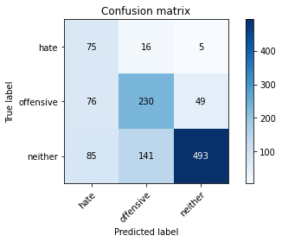

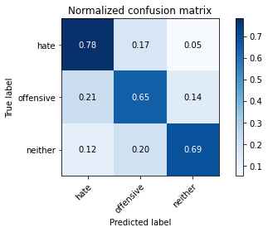

precision recall f1-score support

hate 0.32 0.78 0.45 96

offensive 0.59 0.65 0.62 355

neither 0.90 0.69 0.78 719

accuracy 0.68 1170

macro avg 0.60 0.70 0.62 1170

weighted avg 0.76 0.68 0.70 1170

average eval_loss: 1.18638831326517, accuracy: 0.6820512820512821

training 7 epoch...

16.614954233169556 seconds used......

7 training finished! average train loss: 0.015846225967314758

total clf loss: 0.6877716237213463 total adv loss: 0.09980851463842555

evaluating...

Confusion matrix, without normalization

[[ 78 17 1]

[ 71 257 27]

[101 178 440]]

Normalized confusion matrix

[[0.8125 0.17708333 0.01041667]

[0.2 0.72394366 0.07605634]

[0.14047288 0.24756606 0.61196106]]

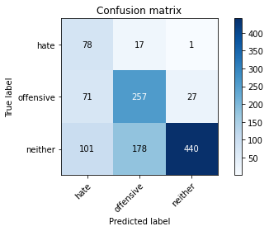

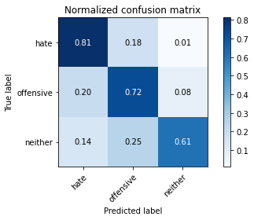

precision recall f1-score support

hate 0.31 0.81 0.45 96

offensive 0.57 0.72 0.64 355

neither 0.94 0.61 0.74 719

accuracy 0.66 1170

macro avg 0.61 0.72 0.61 1170

weighted avg 0.78 0.66 0.69 1170

average eval_loss: 1.5175885780382965, accuracy: 0.6623931623931624

training 8 epoch...

16.569432258605957 seconds used......

8 training finished! average train loss: 0.04534211090192132

total clf loss: 1.1335903531871736 total adv loss: 0.7027839217334986

evaluating...

Confusion matrix, without normalization

[[ 85 8 3]

[101 198 56]

[103 94 522]]

Normalized confusion matrix

[[0.88541667 0.08333333 0.03125 ]

[0.28450704 0.55774648 0.15774648]

[0.14325452 0.13073713 0.72600834]]

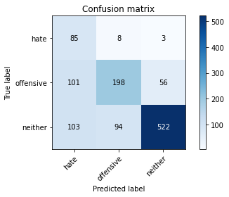

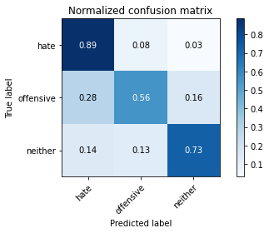

precision recall f1-score support

hate 0.29 0.89 0.44 96

offensive 0.66 0.56 0.60 355

neither 0.90 0.73 0.80 719

accuracy 0.69 1170

macro avg 0.62 0.72 0.62 1170

weighted avg 0.78 0.69 0.71 1170

average eval_loss: 1.2572030223022073, accuracy: 0.688034188034188

training 9 epoch...

16.62890625 seconds used......

9 training finished! average train loss: 0.14788539537195383

total clf loss: 3.1711086607538164 total adv loss: 2.555236825486645

evaluating...

Confusion matrix, without normalization

[[ 82 10 4]

[102 163 90]

[103 43 573]]

Normalized confusion matrix

[[0.85416667 0.10416667 0.04166667]

[0.28732394 0.45915493 0.25352113]

[0.14325452 0.05980529 0.79694019]]

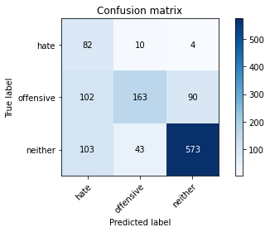

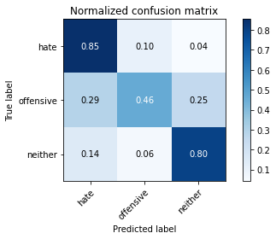

precision recall f1-score support

hate 0.29 0.85 0.43 96

offensive 0.75 0.46 0.57 355

neither 0.86 0.80 0.83 719

accuracy 0.70 1170

macro avg 0.63 0.70 0.61 1170

weighted avg 0.78 0.70 0.72 1170

average eval_loss: 1.1001612816826771, accuracy: 0.6991452991452991

training 10 epoch...

16.586384057998657 seconds used......

10 training finished! average train loss: 0.061914980166225826

total clf loss: 1.5261404273333028 total adv loss: 0.9705492339417106

evaluating...

Confusion matrix, without normalization

[[ 78 13 5]

[ 76 236 43]

[ 87 118 514]]

Normalized confusion matrix

[[0.8125 0.13541667 0.05208333]

[0.21408451 0.66478873 0.12112676]

[0.12100139 0.16411683 0.71488178]]

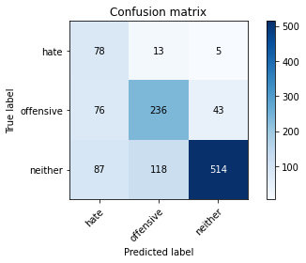

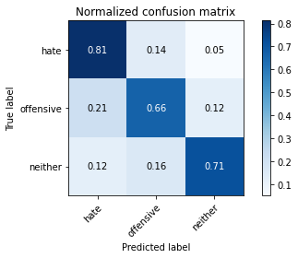

precision recall f1-score support

hate 0.32 0.81 0.46 96

offensive 0.64 0.66 0.65 355

neither 0.91 0.71 0.80 719

accuracy 0.71 1170

macro avg 0.63 0.73 0.64 1170

weighted avg 0.78 0.71 0.73 1170

average eval_loss: 1.2038666449360929, accuracy: 0.7076923076923077